**CALL FOR PAPERS**

Special Session on ‘XXX’ **(Please add here the Title of the special session)**

**2024 7th Artificial Intelligence and Cloud Computing Conference**

**Conference Website:** [**https://www.aiccc.net/**](https://www.aiccc.net/)

**December 14-16, 2024 | Tokyo, Japan**



**Conference Venue: International Conference Center-Waseda University**

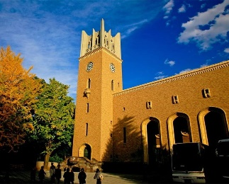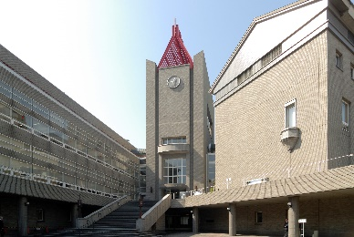

**ORGANIZED AND CHAIRED by**

Organizer 1 name and affiliation

Email address

Organizer 2 name and affiliation

Email address

**SPECIAL SESSION DESCRIPTION** (no more than 150 words)

Please add a short description of the topic

**TOPICS COVERED** (no more than 5)

* Topic 1
* Topic 2
* Topic 3
* Topic 4
* Topic 5

**Schedule:**

Deadline for submission of the paper (s) to the Electronic Submission System by selecting the desired special session – September 10, 2024

Notification of acceptance – September 30, 2024

Supported by:



Published by:



Indexed by:  
 