**CALL FOR PAPERS**

Special Session on ‘XXX’ **(Please add here the Title of the special session)**

**2025 8th Artificial Intelligence and Cloud Computing Conference**

**Conference Website:** [**https://www.aiccc.net/**](https://www.aiccc.net/)

**December 20-22, 2025 | Tokyo, Japan**

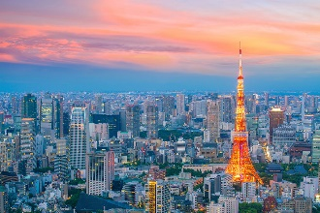

**Conference Venue: Tokyo University of Agriculture and Technology (Koganei campus), Tokyo, Japan**

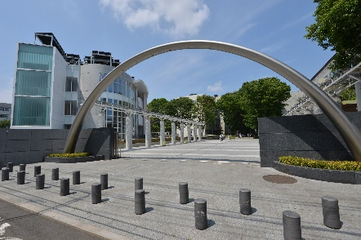

**ORGANIZED AND CHAIRED by**

**SPECIAL SESSION DESCRIPTION** (no more than 150 words)

Please add a short description of the topic

**TOPICS COVERED** (no more than 5)

* Topic 1
* Topic 2
* Topic 3
* Topic 4
* Topic 5

**Schedule:**

Deadline for submission of the paper (s) to the Electronic Submission System by selecting the desired special session – July 10, 2025

Supported by

